Docker images and containers

Open git bash vagrant up and vagrant ssh
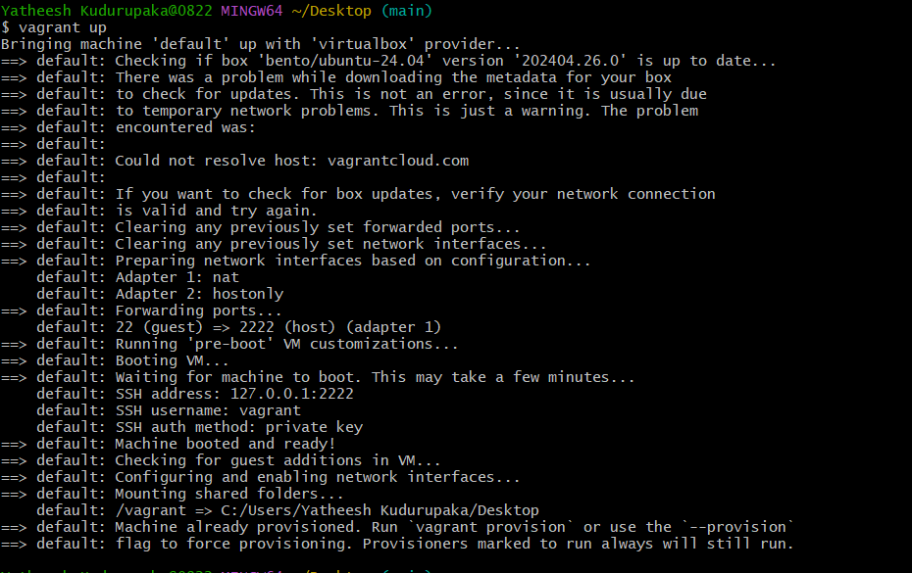
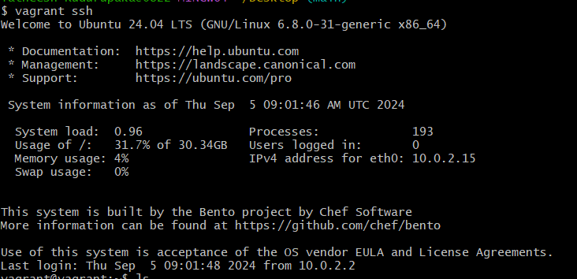
Git clone ems application from github repository
ls
cd ems application
ls
1, first I creating image to ui front end application so I go to ui;
cd ui
ls
sudo vi Dockerfile
heare open the mt page write the content like past the under content,
this script was only 10 7 0 version npm,
FROM node:18-alpine3.20
WORKDIR /reactapp
COPY package.json /reactapp
COPY package-lock.json /reactapp
RUN npm install
COPY . .
RUN npm run build
EXPOSE 3000
CMD [“npm”,”start”]
This is 10 9 0 version script,
FROM node:18-alpine3.20
WORKDIR /reactapp
COPY package.json /reactapp
#COPY package-lock.json /reactapp
RUN npm cache clean --force
RUN npm install
COPY . .
RUN npm run build
EXPOSE 2801
CMD [“npm”,”start”]

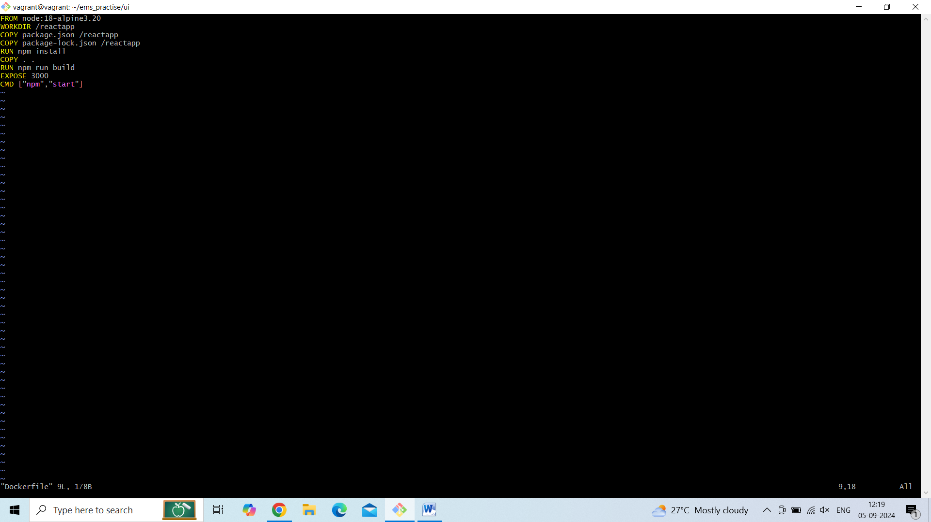
Then save
esc key and type this content -- :wq!
Now create image ;
Sudo docker build –t [your image name, this is your choice], my image name is --- ui-image,
[or]
sudo docker build -t ui_image .

after run this commad sudo docker build -t ui_image . displayed the like this

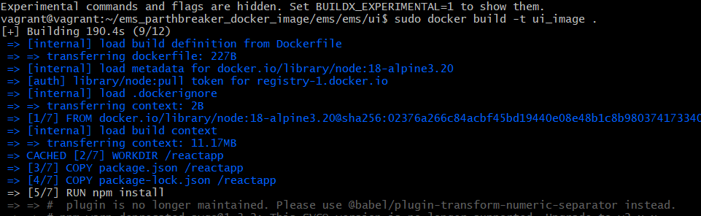

Check the image is creating or not command ;
Sudo docker images [how many images there we check like this command],
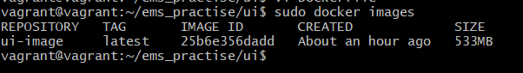
Now run the container ;
Sudo docker run -d –p 3000:3000 <image name or id> [heare give our image name or image id ], I give my image name my image name is ui-image,
How to remove containers :
Sudo docker rm –r <container name>

How many containe is there inside check this command ;
Sudo docker ps -a
Open the browser enter the ip address [192.168.36.10:3000] with port number given in the command,
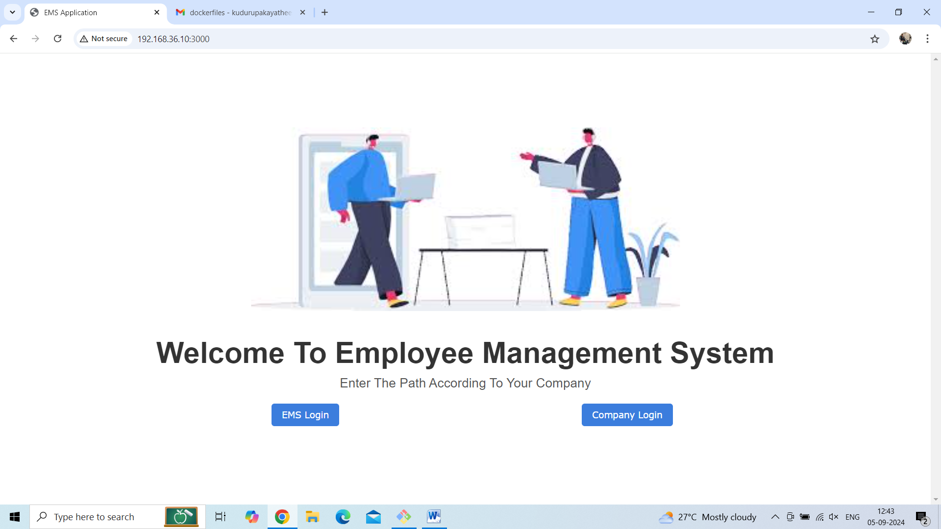
Ems application ui frontend application image creating completed,
==================================================================================
2 employee ;
Same process
Cd employee
Cd employee
ls
Heare create one dockerfile like this down side,
Sudo vi Dockerfile
Write the content ; past the down side content first read the content and explore after past it,
FROM openjdk:21-jdk-slim
WORKDIR /app
COPY gradle /app/gradle
COPY gradlew /app/
COPY build.gradle /app/
COPY gradle.properties /app/
COPY settings.gradle /app/
RUN chmod +x gradlew
COPY src /app/src
RUN ./gradlew build
RUN cp /app/build/libs/employee-1.0.0.jar /app/
EXPOSE 8090
CMD [“java”, “-jar”, “/app/employee-1.0.0.jar”]
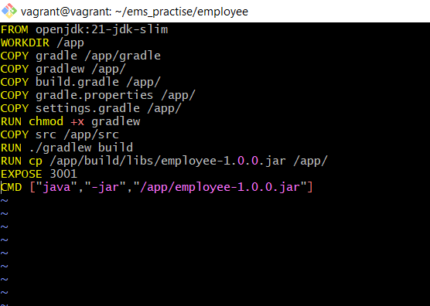

after create to the image,
sudo docker build –t [hour image name it is your choice after giving image name put on dote [.]] my image is employee-image .

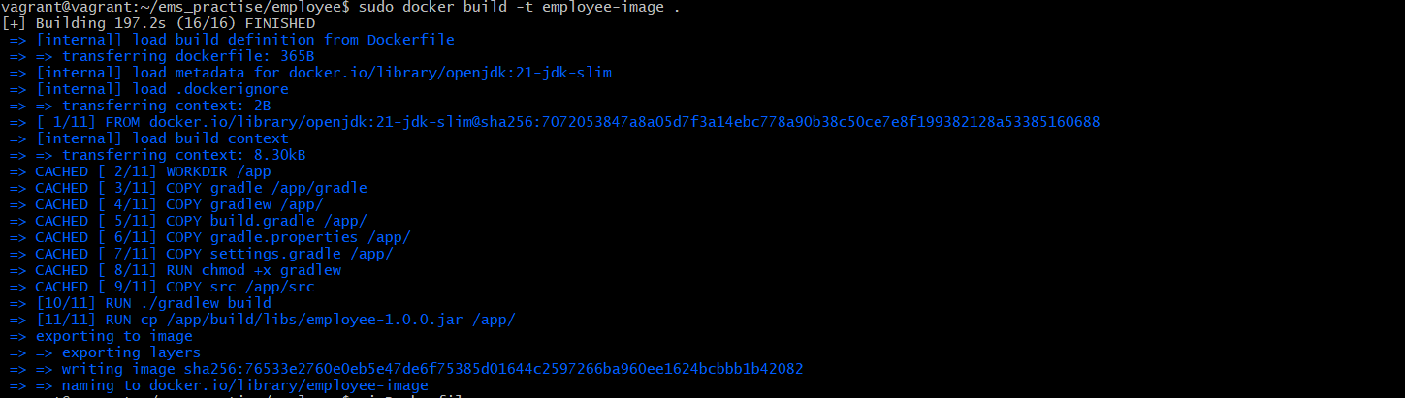
Checke the image is create or not
Sudo docker images
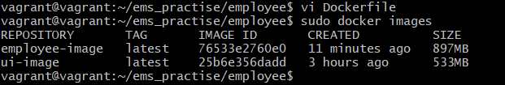
Now run to the container, give to the port number and give to the your image name or image id,
Sudo docker run –d –p 3001:3001 employee-image
Sudo docker ps –a

Running containers :
Sudo docker container ls
How to remove containers :
Sudo docker rm –r <container name>
I have to container so I remove to the one container
192.168.36.10:3001



==================================================================================
3,identity;
Go to the ems application
Ls
Cd identity
Ls
Sudo vi Dockerfile

FROM openjdk:21-jdk-slim
WORKDIR /app
COPY gradle /app/gradle
COPY gradlew /app/
COPY build.gradle /app/
COPY gradle.properties /app/
COPY settings.gradle /app/
RUN chmod +x gradlew
COPY src /app/src
RUN ./gradlew build
RUN cp /app/build/libs/employee-1.0.0.jar /app/
EXPOSE 8191
CMD [“java”, “-jar”, “/app/employee-1.0.0.jar”]

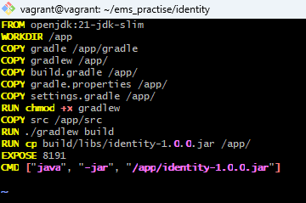
Then save,

Write the content like down side content, and save
Sudo docker build -t employee-image .
checke images how many there,
Sudo docker image

Run to the container
Sudo docker run –d –p 3002:3002 <image name or image id>

How to remove containers :
Sudo docker rm –r <container name>

Check how many containers there
Sudo docker ps –a

Check how many containers running
Sudo docker container ls

192.168.36.10:3003
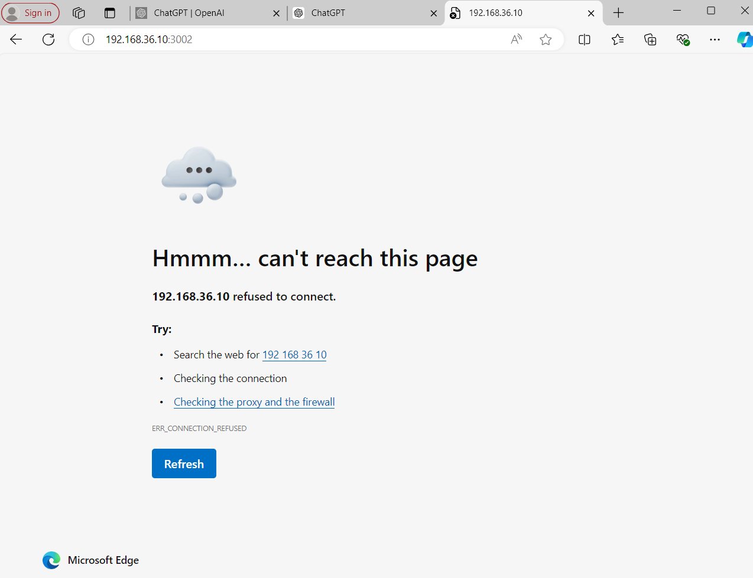
Network creating and compoes ;
Creare network :
The Docker Network command is the main command that would allow you to create, manage, and configure your Docker Network.
sudo docker network
CREATE
sudo docker network create --driver <driver-name> <bridge-name>
My network name is my_network
Sudo docker network create my_network
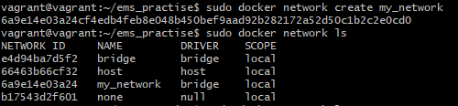

Check network create or not,
Sudo docker network ls
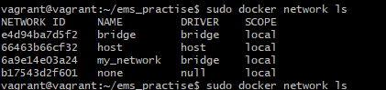

How to connect networks containers,
CONNECT
connect a running Docker Container to an existing Network.
sudo docker network connect <network-name> <container-name or id>
Sudo docker connect my_network unruffled_einstein
This is = unruffled_einstein
Network = my_network
Do the inspect ;
Sudo docker network inspect my_network

How to stop down and up the container ;
Up the compose all containersin side up,
Sudo docker compose up -d
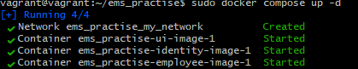
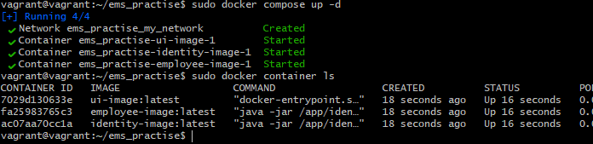

Check the containers up or down
Sudo docker container ls
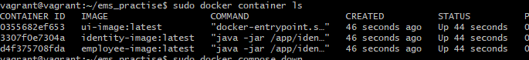

Stop the containers
Sudo docker compose down
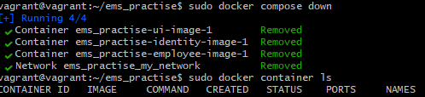

Check the containers stop or not
Sudo docker container ls



